Brush Coil Cleaner
DTBC 2200

Strip Spray Lubrication System
EPCNT 2200

Blanks Cleaner for Staker
DTBCT 2200

1. GENERAL DESCRIPTION 2
1.1. CUSTOMER TECHNICAL DATA 3
1.2 MACHINES TECHNICAL DATA 3
2. MAIN HOUSING 4
3. GENERAL DESCRIPTION COIL BRUSH CLEANER 5
4. GENERAL DESCRIPTION REOILER 8
5. GENERAL DESCRIPTION BLANK BRUSH CLEANER 11
6. GENERAL SPECIFICATIONS AND CONDITIONS 14

GENERAL DESCRIPTION

The scope of supply for this quotation consists in the detailed design, procurement, fabrication and assembly of auxiliary elements related to the below description of material and in-house testing.
The machine is suitable for the installation on a blanking line.
The proposal is composed from:

Brush Cleaner for the coil
Oiler for the Coil
2 Separate Units of Brushes modules for a cleaning of blank on the stacker conveyors

While running through the cleaner, the coil is cleaned on both sides by linear brushes. The dirt is stripped out from the brushes transported into a filter by suction system. These results are possible thanks to:
- mechanical brush effect by the linear brush
- capillary adhesive forces between micro- moistened filament and particle
- reduction of electrostatic charges brought about by the DTBR_300liquid.
While the coil is running through the spray box the upper and lower side can be sprayed with deep drawing oil media with adjustable quantities. The special design of the suction system will prevent contaminated air from escaping through infeed and outfeed slot and the oil collected return back into the oil reservoir. The special design of the suction system also prevents the spray oil mist drops accumulation on the inside walls of the spray chamber from dropping on the passing coil.
For easy maintenance on the oiler the upper and bottom spray heads are extractable.
A third part of the proposal are 2 single brush to install on a different position of the stacker in order to clean the upper and bottom side of blanked blanks.

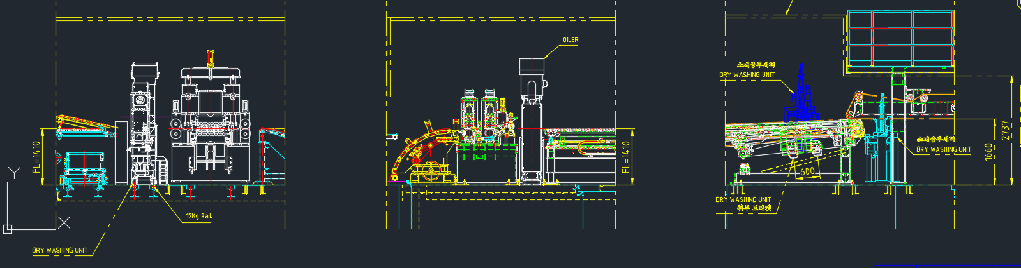

DTBCT 2200
2 Separate units on the conveyors for blanks cleaning before the Staker
EPCNT 2200
Oiler for the coil

DTBC 2200
Brush Cleaner for the coil

1.1. CUSTOMER TECHNICAL DATA

Type of materials | Steel, Aluminum
Thickness | 0,5 – 3,2 mm for Steel  0,5 – 4 mm for Aluminum
Max Thickness delta | 2 mm
Material width (left to right) | Min 300 - max 2200 mm
Material shape | Coil
Working speed | Max 150 m/min
Total installed power supply brush cleaner | 8 kW
Total installed power supply reoiler | 5 kw
Electrical equipment | 440V, 60 Hz, 3 phases, N, PE (different voltage available)
Safety interface | To be defined
Labelling | Standard Dietronic
Number of oil media | Only 1
Oil media details
Application | Coil

MACHINES TECHNICAL DATA

Coil cleaner power consumption | 10 Kw
Oiler power comsuption | 5 Kw
Blank power comsuption | 5 Kw
Oil valve voltage | 24 V DC
General valve voltage | 24 V DC
Control voltage | 24 V DC
Brush cleaner air consumption | 1200 Nl/min at 6 bar
Reoiler air consumption | 2200 Nl/min at 6 bar
Blank brush cleaner air consumption | 1200 Nl/min at 6 bar
Air Supply (brush cleaner and reoiler) | 5 bar min
Communication with a line | Ethernet, Profinet

MAIN HOUSING

Frame
The machine’s substructure is a solid and waterproof welded steel construction.

Interface points with a press line
The electrics and pneumatics connections pass along the machine side in a cable chain and can be plugged at separate connection boxes (1 for Cleaner,1 for Oiler and 1 for Blank Staker Cleaner). At these connection box the two machines must be connected from the customer side (air supply, power supply, cables interface – Dietronic will provide a document for details).

Cable and Pipe Channels
All channels to connect the connection boxes to the HMI and the connection boxes to the refilling units must be provided from a customer (Dietronic will provide a document for details) as well as the channel to connect the 2 connection boxes.
All cables and pipe from Dietronic side are scope of supply.

Electrical control
The machine operating panel is placed separately according to the line layout.
The control cabinets will be placed separately according to the line layout.

Software
The software is provided in protected mode (only reading mode, not writing mode) until warranty expiration. The default language is English.

Electrics & Control
The communication is Ethernet or Profinet
The control cabinet can be placed on the structure of the machine.
The machine operating panel is placed separately according to the line.

GENERAL DESCRIPTION COIL BRUSH CLEANER

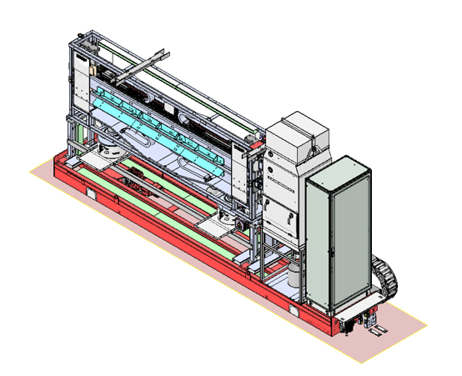

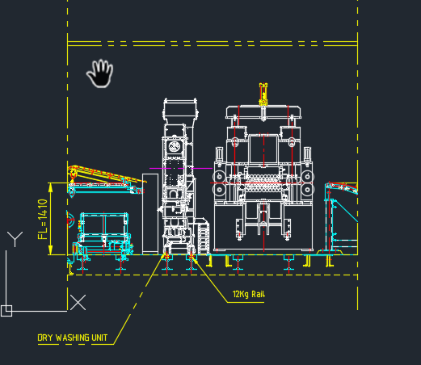

The linear brush wipes transversally across the product surface. Particles will cling to the micro-moistened filaments which will thus remove them effectively and transport them to the suction connection.
These results are possible thanks to:
- mechanical brush effect by the linear brush
-capillary adhesive forces between micro- moistened filament and particle
- reduction of electrostatic charges brought about by the DTBR_300 liquid.
Linear Brushes
Two Sword Brushes, wipe transversally across the material surfaces. The micro-moistened brush filaments (Antistatic Liquid system) remove even the most minute particles from the subject surface. The integrated pressure buffer provides for a constant wiping pressure and a premium cleaning result. The adjustment frame VE 25. allows a vertical adjustment of the Sword Brushes e.g. to adapt them to the material’s thickness or to remove them from the material surface for maintenance purposes.

Pneumatic Height Adjustment
The cleaning module may be mounted on an adjustment frame to integrate a height adjustment:
- Manual adjustment via crank (HVM)
- Electrical adjustment via actuator (HVE). An automatic thickness adjustment is possible if HVE is linked to the overall control
- Pneumatic adjustment via pneumatic cylinder (HVP).
Quick removal of module from material surface, e.g. in crash situations. The mechanical and the electrical height adjustment may be combined with the pneumatic adjustment.
The brushes are supported by pneumatic pistons for fast opening.
A safety device before on the entrance of the machine is connected to the signal to open fast the brushes. The upper brush can be open for 200 mm and the lower for 100 mm.

Self-Cleaning of the Brushes
At the deviation, the linear brushes widen, so that particles may be detached more easily. Rotating steel elements (racks) remove the particles mechanically from the filaments. Additionally, there are com-pressed air driven nozzles, that blow into the brush filaments to cancel the capillary adhesive forces be-tween the particles and the filaments. The suction system will absorb the particles.
Benefit: Improved self-cleaning and automatic cleaning process
Steel and Dry alluminum:
only cyclone with heating
The patented Antistatic liquid system permits effective removal of even very fine particles.

DTBR_300 Cleaning Liquid Applicator
DTBR_300 is an antistatic cleaning agent. The brush filaments are micro-moistened with DTBR_300, thus providing an effective removal of even very fine dust particles
- Micro-moistened brush filament with antistatic liquid
- DTBR_300 sprayer SQL 51.
- Distributor block VTB 100.
- DTBR_300 regulator and filter unit IR 100. DTBR_300 filter, dosage and display of inner pressure of pressure buffer
- DTBR_300 central supply pump, e.g. IS 102
The DTBR_300 liquid is supplied by a pneumatic from on frame tank of 20 lt tank with electric filling level control as well as pump and connections for refilling the reservoir.
Automatic refilling unit for the DTBR_300 tank from barrel or IBC Container 1000 lt.
The unit is provided with level sensor switch displayed on the HMI of the machine.
Calibrated nozzles control the amount of liquid applied on the single brush.
The consumption of the DTBR_300 is estimate in about 2L for hour
BRUSHES SPECIFICATION
NUMBER OF BRUSHES | 8: 2 above, 2 below
FILAMENTS | black filaments in polyamide, length of filaments 17mm, diameter 0,2 mm
SUCTION FILTER | DUSTOMAT 4-10
BRUSH CLEANILESS LEVEL | < 0,5 mm particle size
DTBR_300 RESERVOIR | 50 litres
UPPER BRUSH HEIGHT ADJUSTMENT | automatic positioning of the upper brush
SAFEY BRUSH DEVICE | laser sensor for anti coil collision control for upper and lower brush (Dietronic will provide sensor and support, THE CUSTOMER will install on the infeed conveyor)

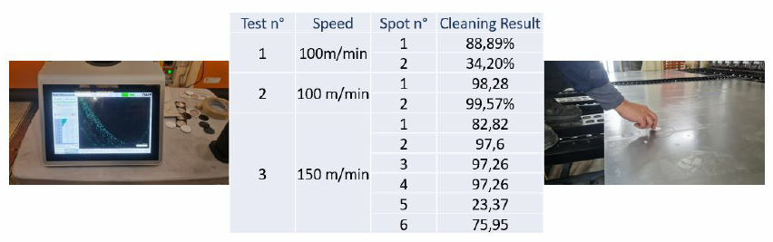
Cleaning performance 98% of particulars removal below 50 micro is required.
We can only confirm this requirement, when certain basic surface conditions are defined.
The cleaning results also can be influenced from initial conditions of the material.

GENERAL DESCRIPTION REOILER

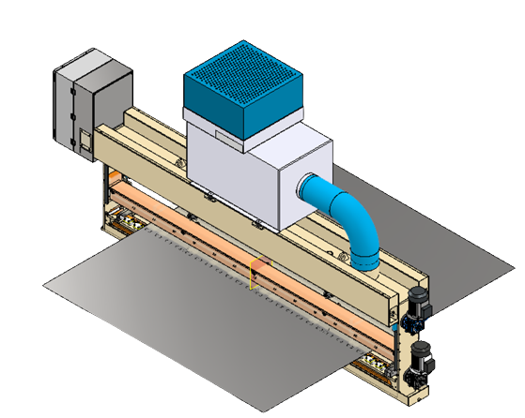

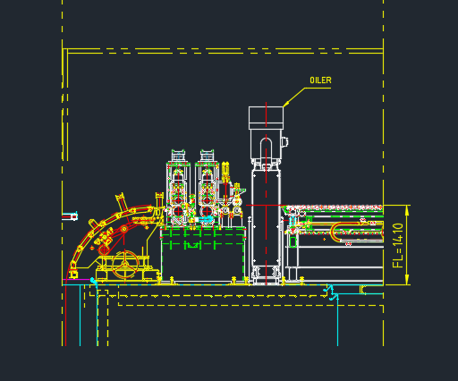
The machine is created to apply very accurate forming lubricants onto coils with adjustable quantities (from 0,5 up to 5 g/m2).

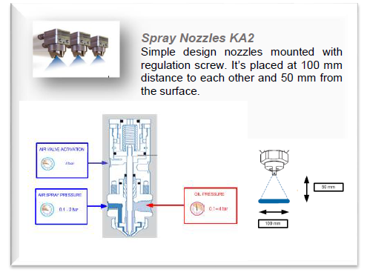
Spray Heads Composition The inside of the spray box is designed to prevent spray-oil mist drops depositing on the inside walls of the spray box from dropping onto the passing coil. Inside the spray box there are an upper and a lower extractable and isolated spray head that contains LVLP automatic spray gun. The extraction of the spray heads is from the side of the machine for very easy maintenance.
Every spray head has 22 LVLP automatic spray gun at 100 mm distance in between, with a perfect quality of spray application and minimum overspray, due to the minimum distance from the coil surface (just 50 mm).

Oil Mist Extraction System
A suction system is mounted on the top of the machine. Air is extracted from the machine housing by means of a fan. This will prevent contaminated air from escaping through infeed and outfeed slots. Oil-mist separators clean the extracted air and return the oil back into the reservoir.
The inside of the spray box is designed to prevent spray-oil mist drops depositing on the inside walls of the spray box from dropping onto the passing coil.
A high efficiency filter (the combination of polyester fabric and Teflon), also allows the removal of smokes and vapors, providing filtration efficiencies reaching the remarkable value of 99,9%, IFA-BGIA Certification. All models are equipped with a differential pressure gauge to monitor the filter life.

Internal Cleaning Wiper
Automatic device to clean the inside walls of the spray chamber. The wiper is activated from the operator panel and moves along the edge of the walls preventing the accumulation of oil drops.

Oil Quantity Programmability and Spray Intensity
The usual intensity application of deep drawing oil in the automotive press shop is approx.
< 0.5 – 1,5g/m². This variation is connected to the adjustable oil pressure.

Oil Media Reservoirs and Oil Media Pressure Control
The machine is equipped with 40 lt oil tanks and by a pneumatic pump an accumulator of 2 litres is automatically refilled and maintained at constant fix level. With air pressure on this accumulator automatically controlled from the HMI is possible to set a very constant oil pressure to the spray heads.
An additional recovery tank of 40 lt permits to collect the oil from the tray of the machine and with a pneumatic pump this oil is filtered 10 µ and automatically refilled to the main tank.
Automatic refilling units for the Oil media tanks from barrel or IBC Container 1000 lt.
The unit is provided with level sensor switch displayed on the HMI of the machine.
Air Pressure Control
The air pressure is completely automatic, no manual action is needed, adjustable from the operator panel.

STRIP OILER SPECIFICATION
NUMBER OF SPRAY NOZZLES | 22 upper side, 22 bottom side (total 44 pcs.)
SMALLEST SINGLE SPRAY STRIP | 100 mm
OIL QUANTITY APPLICATION RANGE | 0,5 – 5 g/m²
NUMBER OF FREELY PROGRAMMABLE INTENSITIES UPPER AND LOWER SIDES | adjustable quantities
OIL RESERVOIR | 40 lt
WASTE OIL RECOVERY TANK | 40 lt
OIL FILTER | filter 10 micron
HIGH EFFICENCY SUCTION FILTER | Included– 0.35 kW each; 2500 m³/h with analogic pressure gauge
EASY MAINTENANCE SOLUTION | extraction of the complete spray head from the side of the machine.
ANTI DROP SYSTEM | internal pneumatic wiper for the collection of the small drops’ accumulation

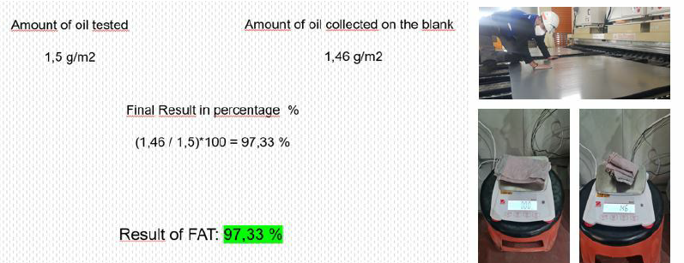

GENERAL DESCRIPTION BLANK BRUSH CLEANER

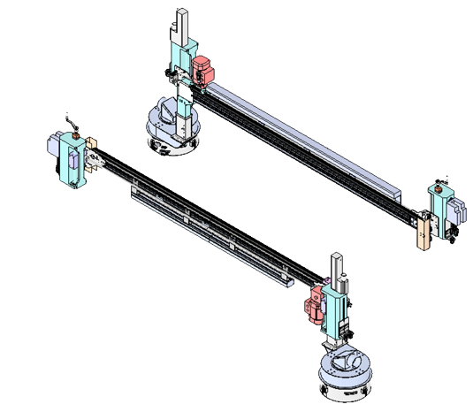

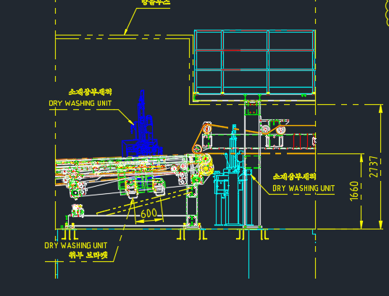
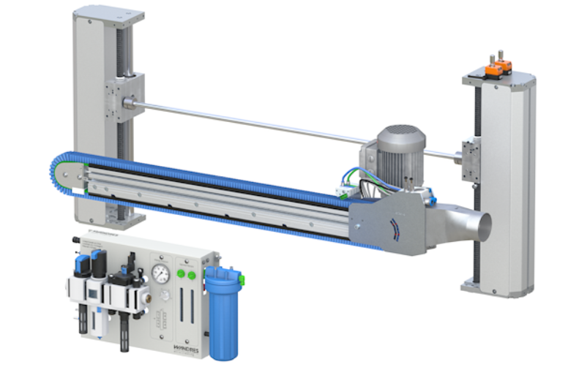
The linear brush wipes transversally across the product surface. Particles will cling to the micro-moistened filaments which will thus remove them effectively and transport them to the suction connection.
These results are possible thanks to:
- mechanical brush effect by the linear brush
-capillary adhesive forces between micro- moistened filament and particle
- reduction of electrostatic charges brought about by the DTBR_300 liquid.

Linear Brushes
Two Sword Brushes (1 upper side and 1 for the bottom side), wipe transversally across the material surfaces. The micro-moistened brush filaments (Antistatic Liquid system) remove even the most minute particles from the subject surface. The integrated pressure buffer provides for a constant wiping pressure and a premium cleaning result. The adjustment frame VE 25. allows a vertical adjustment of the Sword Brushes e.g. to adapt them to the material’s thickness or to remove them from the material surface for maintenance purposes.

Pneumatic Height Adjustment
The cleaning module may be mounted on an adjustment frame to integrate a height adjustment:
- Manual adjustment via crank (HVM)
- Pneumatic adjustment via pneumatic cylinder (HVP).
.
The brushes are supported by pneumatic pistons for fast opening.
A safety device before on the entrance of the machine is connected to the signal to open fast the brushes. The upper and bottom brush can be open for 50 mm.

Self-Cleaning of the Brushes
At the deviation, the linear brushes widen, so that particles may be detached more easily. Rotating steel elements (racks) remove the particles mechanically from the filaments. Additionally, there are com-pressed air driven nozzles, that blow into the brush filaments to cancel the capillary adhesive forces be-tween the particles and the filaments. The suction system will absorb the particles.
Benefit: Improved self-cleaning and automatic cleaning process
Steel and Dry aluminum:
only cyclone with heating
The patented Antistatic liquid system permits effective removal of even very fine particles.

DTBR_300 Cleaning Liquid Applicator
DTBR_300 is an antistatic cleaning agent. The brush filaments are micro-moistened with DTBR_300, thus providing an effective removal of even very fine dust particles
- Micro-moistened brush filament with antistatic liquid
- DTBR_300 sprayer SQL 51.
- Distributor block VTB 100.
- DTBR_300 regulator and filter unit IR 100. DTBR_300 filter, dosage and display of inner pressure of pressure buffer
- DTBR_300 central supply pump, e.g. IS 102
The DTBR_300 liquid is supplied by a pneumatic from on frame tank of 20 lt tank with electric filling level control as well as pump and connections for refilling the reservoir.
Automatic refilling unit for the DTBR_300 tank from barrel or IBC Container 1000 lt.
The unit is provided with level sensor switch displayed on the HMI of the machine.
Calibrated nozzles control the amount of liquid applied on the single brush.
The consumption of the DTBR_300 is estimate in about 2L for hour.

BRUSHES SPECIFICATION
NUMBER OF BRUSHES | 2: 1 above, 1 below
FILAMENTS | black filaments in polyamide, length of filaments 17mm, diameter 0,2 mm
SUCTION FILTER | OEL-DS-1-0,28
BRUSH CLEANILESS LEVEL | < 0,5 mm particle size
DTBR_300 RESERVOIR | 50 litres
SAFEY BRUSH DEVICE | laser sensor for anti coil collision control for upper and lower brush (Dietronic will provide sensor and support, THE CUSTOMER will install on the infeed conveyor)

According to the specification M&E 20-05 Rev.1 a 98% of particulars removal below 50 micro is required.
We can only confirm this requirement, when certain basic surface conditions are defined.
The cleaning results also can be influenced from initial conditions of the material.

GENERAL SPECIFICATIONS AND CONDITIONS

Certification: | QUASI MACHINE 2006/42/CE Machine Directive
Labelling: | DIETRONIC Standard
Electrical schemes and drawings: | PDF
Notes: | The software will be provided with comments only in English language.  Until warranty expiration it will be provided only in readable version.  Intellectual proprieties key-blocks of the program will be protected under password.
Cables Standard Length | Cable length between EC oiler and cleaner to the HMI 20 m

Integration exclusion:
-Downloading from truck
-Positioning on existing rail of the machine. DieTronic is not responsible about rails condition and alignment
-Re-assembling of parts dismounted for transportation (DieTronic supervision included)
-All the activities that require to fix on the concrete
Referred for sensor IN/OUT of the machine from the line
Cable chain
Connection box
-Communication devices and cable for software interface between our machine and the line including cable channels
-Software integration to the line
-Positioning of IBS or Barrel holder
-Channels and installation for flexible pipes to connect the Antistatic liquid from the IBC or Barrel holder to the connection box (flexible pipes included)
-Channels and installation for cables to connect the machine from connection box to the HMI pulpit (cables included)
-Installation and bracket of crash sensor
Cable for the sensor
Interface between the crash signal from the line to our machine
-Power supply and cable from the line to the connection box
-Piping for air supply from line to the connection box

Warranty Conditions:
The Warranty goes into effect after maximum 60 days from when the new Dietronic unit has been delivered to the customer premises and expires at the end of the Warranty Period specified above.
The Warranty covers repairs to correct any unit defects related to materials or workmanship existing at the time of purchase. All requests must be approved by Dietronic prior to any work being performed during the Warranty Period. Specific exceptions to the Warranty are listed in the Exclusions section.
Dietronic will provide repairs to the unit during the Warranty Period in accordance with the Terms, Limitations, and Conditions. This is the sole Warranty provided by Dietronic.

Exclusions
Unit components subject to normal wear during the Warranty Period are not covered by Warranty and include the following items:

1.Filters (Oil tank, Antistatic liquid tank, brush cleaner and reoiler suction systems filters)
2. Brushes
Component failure caused by customer misuse/abuse of the unit (e.g. incorrect modification of machine parameters that cause damages or the usage of incompatible materials), voids the Warranty.
Machine rupture caused by part handling/misuse or damages due to exposure to elements or incorrect storage of the equipment, voids the Warranty.

Standard Equipment Warranty Coverage
All unit components are warranted for 1-Year, except the items listed in the Exclusions section.
Dietronic will supply new or remanufactured component of equal or better quality to replace the failed component. It is the sole discretion of Dietronic to determine best method of replacement. The replaced component will be covered for the remainder of the Warranty Period or 90 days, whichever is longer.

Commissioning Conditions:
Date after agreement with MrS. Elisa Beccaria (service@dietronic.eu)
The following preconditions need to be met for a successful commissioning:
1) The Machine has to be mounted and aligned
2) The electrical, pneumatic and liquid connections must have been installed
3) Electricity and compressed air should be available according to Dietronic specification
4) Free access to 230 V.
5) Customer must provide necessary safety training and access cards
6) Customer must guarantee working time without interruptions for Dietronic technicians
7) Commissioning will take place only once in Customer Plant
8) Working time 7 am to 5 pm, if technicians need to work extra hours we will charge surpluses for night shifts or work during the weekends.

Scope of commissioning:
1) Functional control of the installation
2) Initial start-up of the system

Not included in the above price are the following items:
1) All sorts of mounting and installations works
2) Correcting mounting errors or deviations from Dietronic specifications

All waiting periods that go back to external factors or to non-compliance with the preconditions for a successful
commissioning will be invoiced according to the Dietronic price-list for technicians An authorised person of the
customer will have to confirm that the above services have been rendered directly after the end of the commissioning.
This must be done on the Dietronic form "confirmation commissioning". This confirmation ends the commissioning, the risk for running the machine will pass on to the customer.
A separate trip of the technicians to receive the customer's or end-customer's final acceptance is not included in this quotation/ order confirmation.
All additional services or items, that are not included in this quotation/ order confirmation will be charged according to the Dietronic price-list for technicians.

